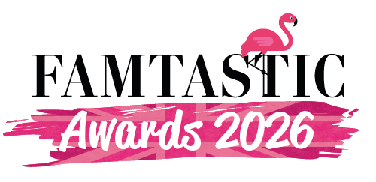
Sponsorship Information
Friday 30 October 2026 | Cedar Court | Bradford
The Awards
Designed to recognise amazing agents and super suppliers, the Famtastic Awards are back for 2026, and a refreshing addition to our industry calendar, with a serious business message, enabling our winners to have some amazing PR opportunities around their success.
With a simple, free entry process, transparent judging policy, and the appointment of some amazing industry individuals on board, this is a fantastic way to get your brand in front of a relevant and receptive audience – whether you win or lose with the entries!
Famtastic is all about engagement and making new connections and enhancing existing contacts and the format of the event, underlines our commitment to this policy.
The Format
We’ve introduced a few morning workshops this year, designed to educate and engage event profs, which be followed by lunch, and then an afternoon of informal speed dating. It’s then the awards drinks reception will be followed by a glittering evening celebrating our industries finest.
Discounted Accommodation rates for the suppliers are available.
We’re embracing a Brit Pop vibe for the evening event!

The Categories
- Famtastic Academic Venue of the Year
- Famtastic Agent of the Year
- Famtastic Agency of the Year
- Famtastic Bedroom of the Year
- Famtastic Boardroom of the Year
- Famtastic Caterer of the Year
- Famtastic Conference Centre/Hotel of the Year
- Famtastic Convention Centre/Bureau of the Year
- Famtastic Green Initiative of the Year
- Famtastic Freelancer of the Year
- Famtastic Hotel Brand of the Year
- Famtastic Independent Hotel of the Year
- Famtastic International Representation of the Year
- Famtastic Independent Venue of the Year
- Famtastic Marketing of the Year
- Famtastic New Talent of the Year (A)
- Famtastic New Talent of the Year (S)
- Famtastic Refurbishment of the Year
- Famtastic Representation of the Year
- Famtastic Sales Professional of the Year
- Famtastic Sports Venue of the Year
- Famtastic Team Building Company of the Year
- Famtastic Unique Venue of the Year
- Famtastic Use of AI or Event Tech

Attending and Sponsorship Opportunities
- Lunch & Speed Dating for One £395+vat
- Lunch & Speed Dating for Two £470+vat
- Workshops, Lunch & Speed Dating for One £425+vat
- Workshops, Lunch & Speed Dating for Two £495+vat
- Additional Speed Dating Person £95+vat
- Awards Tickets £150+vat

Option One Headliner Sponsors £3250+vat
- A Table of 10 at the Awards and access to the judges and guest list to invite agents
- Up to five speed dating tables during the afternoon
- Branding on the website, in print and on screen at the event
- Prime table location
- Choice of Two Categories to present on the night

Option Two £2750+vat
- A Table of 10 at the Awards and access to the judges and guest list to invite agents
- Branding on the website, in print and on screen at the event
- Prime table location
- Choice of Category to present on the night
Option Three £1950+vat
- A Table of five at the Awards and access to the judges and guest list to invite agents
- Two speed dating tables/two places during the afternoon
- Branding on the website, in print and on screen at the event
- Prime table location
- Choice of Category to present on the night
Option Four £1775
- A Table of five at the Awards and access to the judges and guest list to invite agents
- Branding on the website, in print and on screen at the event
- Prime table location
- Choice of Category to present on the night
Ideas Welcome
We also welcome any ideas or suggestions how to make the event as Famtastic as possible, so we are open to contra arrangements and input from all of the wonderful Famtastic people working in events.
Please Contact
Cathryn famtastic.rocks@cloud9em.co.uk
Paula paula@cloud9em.co.uk

